Week 1
🔰 Beginning

Week 1 started with an introduction of the fundamentals of computer networking with GNS3. I also lacked the real-life experience in setting up networks, particularly in a virtual setup. The activities were aimed at learning how to establish a basic network topology in Linux hosts and an Ethernet switch.

I also started to study IP addressing, such as the format of IPv4 addresses and subnet masks. During this phase, I was not much confident about using manual assignment of IP addresses or the way devices can communicate with each other in the same network.
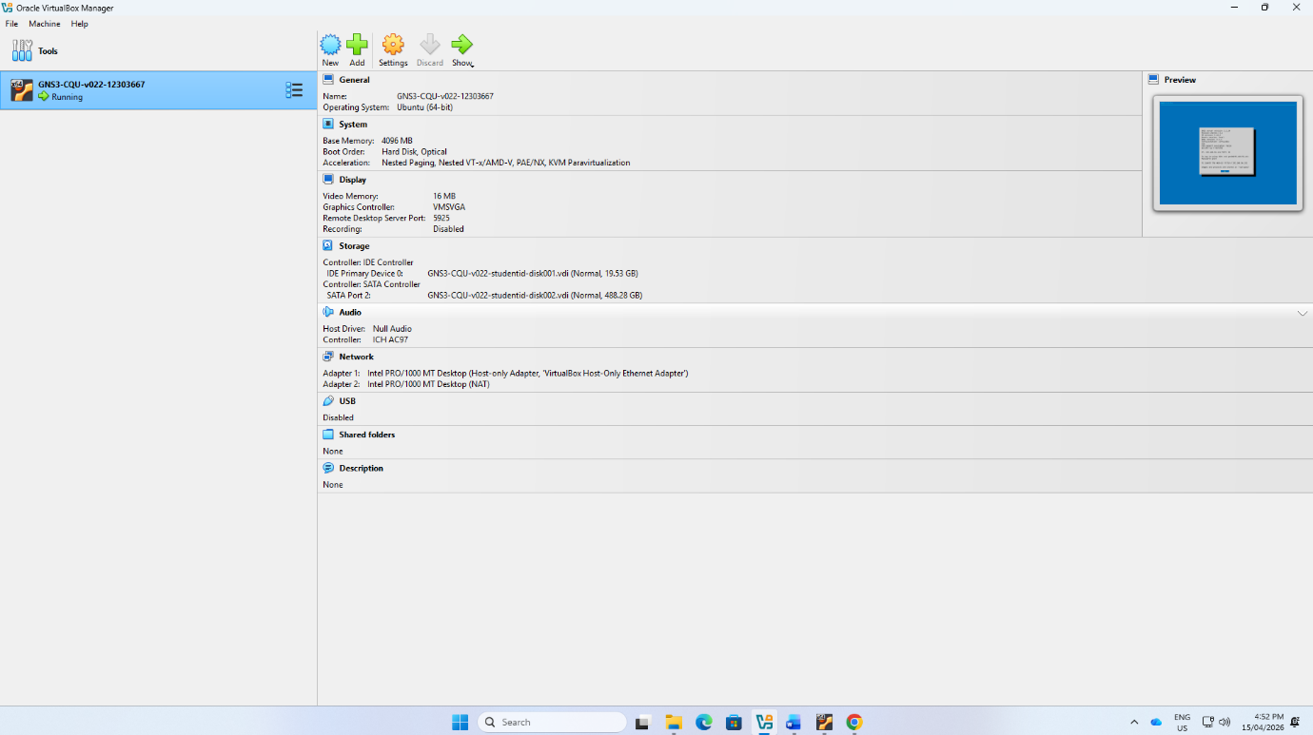
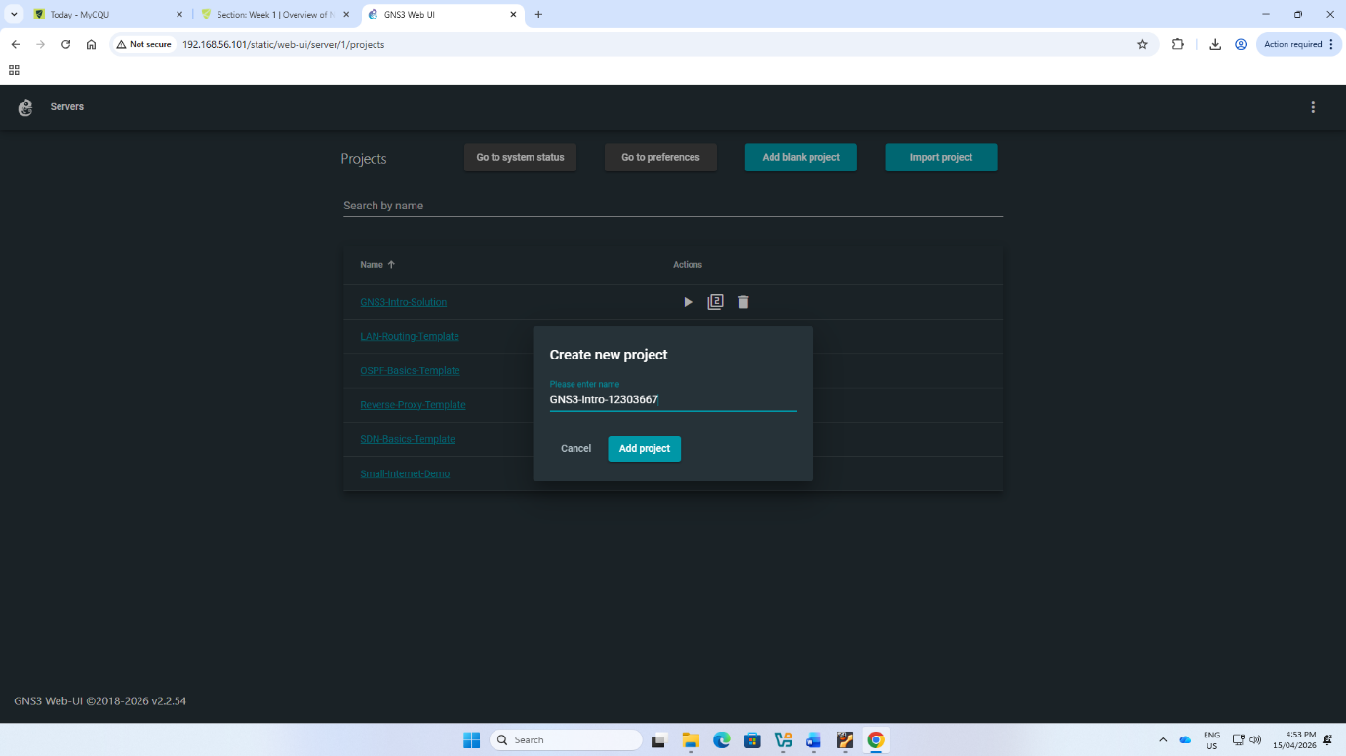
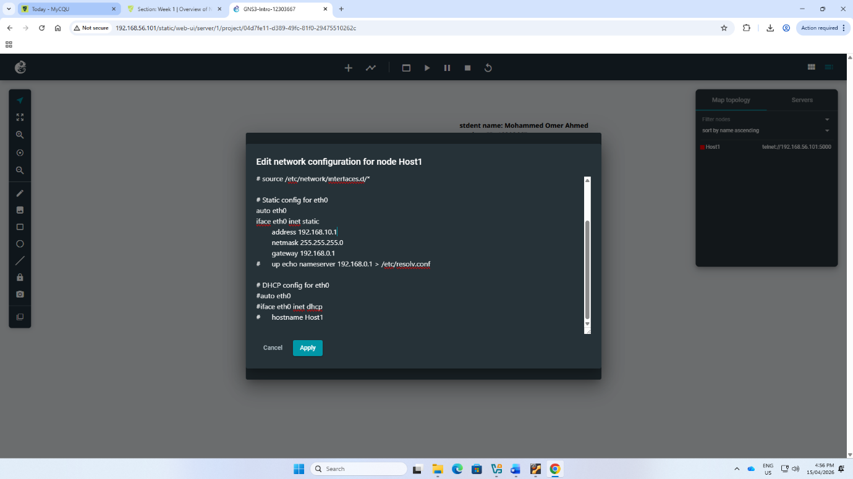
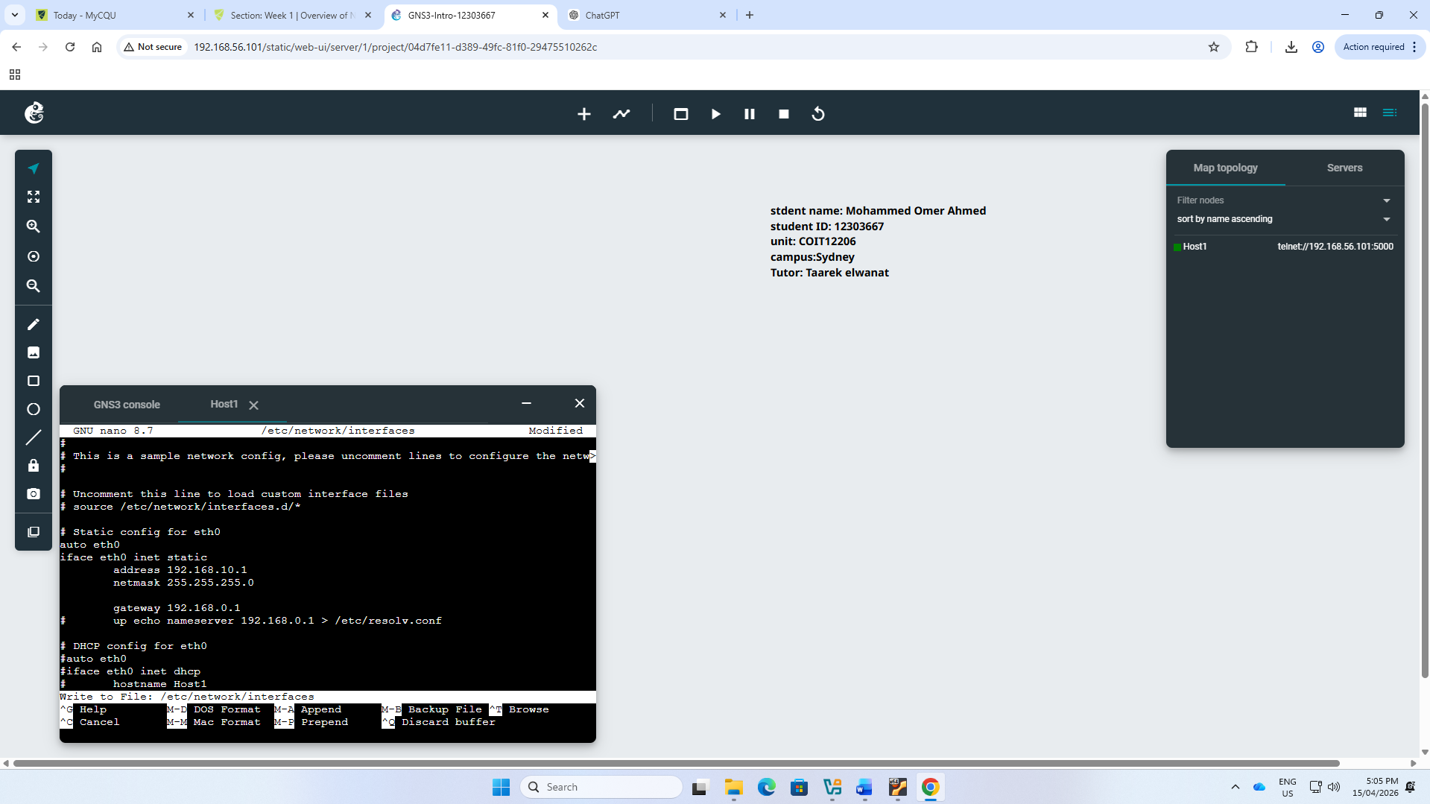
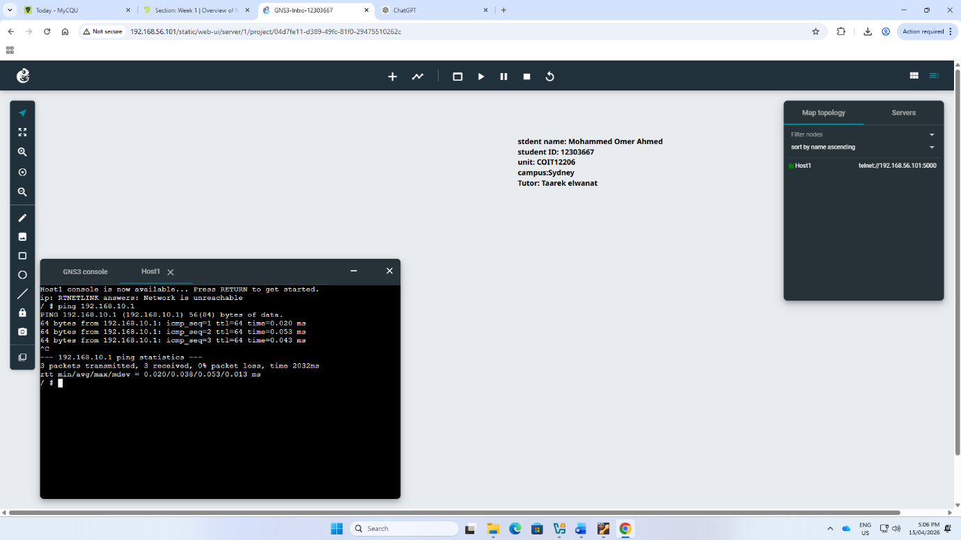
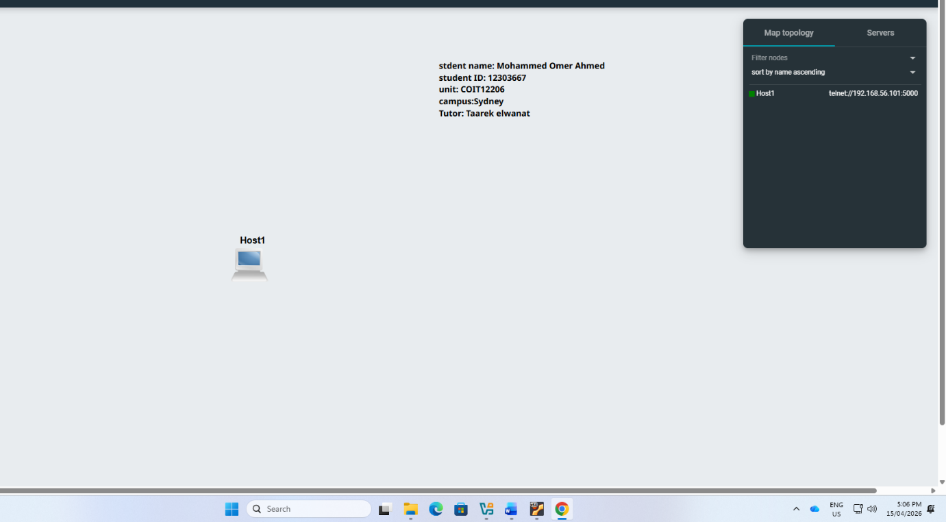

🔁 Reflection

At the conclusion of Week 1, I gained a more insight into the functionality of a local area network (LAN). I was able to construct a network topology on GNS3 and I was familiar with how to assign IP addresses through the graphical interface.

I also developed trust in recognizing the valid IP ranges, and the purpose of subnet mask. Even though the steps to follow during configuration were confusing to me, with practice I got more comfortable. On the whole, Week 1 was a good preparation to work with network configurations.

